Date of report submission: May 10th, 2016
Name of School/College: South University School of Pharmacy
Chapter name and region: Gamma Upsilon- Region III Southeastern
Chapter advisor’s name and e-mail address:
(If chapter has a co-advisor, please list name and email address):
For split campuses, please list advisor and email address for each campus, if applicable:
Dr. Adegoke Adeniji aadeniji@southuniversity.edu (Savannah Campus)
Dr. Sarah Braga sbraga@southuniversity.edu (Columbia Campus)
Delegate who attended the Rho Chi Annual Meeting: Ashley Covert
(Note: Any chapter failing for three successive years to have a delegate at the National Convention shall be declared “inactive” by the Executive Council and may not elect members unless and until reinstated – Article 4, Section 3, Rho Chi Society Bylaws) Note that Advisors attending the National Conventions may serve as delegates in the absence of a student or non-student member delegate—Article 7, Section 7, Rho Chi Society Bylaws.

Date delegate’s name submitted to Rho Chi.: 01/27/16

Past year’s officers and e-mail addresses:
President: Nicklaus McMellon nickmcmellon@yahoo.com
Vice President: John McBride johnmcbride@stu.southuniversty.edu
Secretary: Lindsay Helton lnhelton@stu.southuniversity.edu
Treasurer: Jeb Watkins dr_red@yahoo.com
Historian: Robert Martz rmartz4@stu.southuniversity.edu
New officers and e-mail addresses for next academic year:
(If not yet elected, please indicate date of anticipated election and report names within one week of election)

New officer elections will be held in December, 2016.

President:
Vice President:
Secretary:
Treasurer:
Historian:

Number of Rho Chi student members at college or school, listed by class year and program (and by campus if more than one campus):
Class of 2016 Columbia: 6
Class of 2016 Savannah: 21
Class of 2017 Columbia: 4
Class of 2017 Savannah: 16
Meetings: Provide information on meetings held in the following tabular format (Limit 1.5 page)
Note: If your chapter is part of a split campus, please list the meetings with campus reference under the Attendance (i.e. A, B or 1, 2 with a note to indicate the campus of reference).

Date | Attendance | Agenda | Action Steps
August 8th, 2015 | Rho Chi Members | The meeting was called to order by President Janna Nevil.  Discussion about tutoring, new members and their initiation was held.  Dr. Adeniji was a welcomed as a new Rho Chi advisor on the Savannah Campus. | It was decided to have initiation in Savannah at Chabellas.  Tutoring will continue as it has in the past.
January 6th, 2016 | Rho Chi Members | The meeting was called to order by Janna Nevil.  New officers sworn in.  Discussion about tutoring, ordering graduation chords, selecting a delegate for the National Convention, completing the annual report, student activities fair, a Rho Chi T-shirt, and initiation was discussed.  An amendment to the local chapter by-laws for members to wear their pins on meeting days was discussed. | It was decided to create and order a t-shirt for our local chapter.  An amendment to the local chapter by-laws requiring members to wear pins on meeting days was passed.  Members of both the Savannah and Columbia campus planned to submit forms to become tutors.
February 29th, 2016 | Rho Chi Officers | The meeting was called to order by President Nicklaus McMellon  Discussion and planning of tutoring sessions, white coat fundraiser, a PB&J drive, T-shirt, on campus day with Armstrong State, a quarterly meeting, and a raffle basket for the annual bowling tournament were done.  Ashley Covert was selected as the delegate to the national convention | Rho Chi members in Savannah will help with an on campus day with Armstrong State.  A PB&J drive will be held 11th-15th in conjunction with APhA  White Coats will be sold in April.  The quarterly meeting will be held April 4th, 2016.
April 4th, 2016 | Rho Chi Members | The meeting was called to order by President Nicklaus McMellon.  Discussion and planning of tutoring sessions, white coat fundraiser, a PB&J drive, T-shirt, on campus day with Armstrong State, a quarterly meeting, and a raffle basket for the annual bowling tournament were done.  A scrub day fundraiser benefiting the Savannah Baptist center was discussed. | Members will donate purple jelly and peanut butter and the donations will be given to Savannah Baptist Center.  Columbia Rho Chi members will organize the white coat sells.

Strategic Planning: What goals were set that relate to the Rho Chi mission? (Limit 0.5 page)

Strategic Planning:
The mission of Rho Chi Society is to encourage and recognize excellence in intellectual achievement and advocate critical inquiry in all aspects of pharmacy. The Society further encourages high standards of conduct and character and fosters fellowship among its members. Our chapter’s goals relate directly to the Rho Chi mission.

Our goal is to continue carrying out the tutoring sessions, helping pharmacy students on individual basis when needed, and to encourage more students and members to be part of the Rho Chi activities that include reaching out to the community outside of school. Our community service goal is to continue devoting our time for a cause in the community by interacting and working with the other chapters on the campus and plan to attend events on and off the campus.

We also plan to reach out to the undergraduate schools as well as high schools in the local area. This would help the students that are interested in pursuing a pharmacy career in the future and also get better recognition for the Pharmacy profession within our community.. Our main goal is to continuing to better serve our fellow pharmacy students and community.
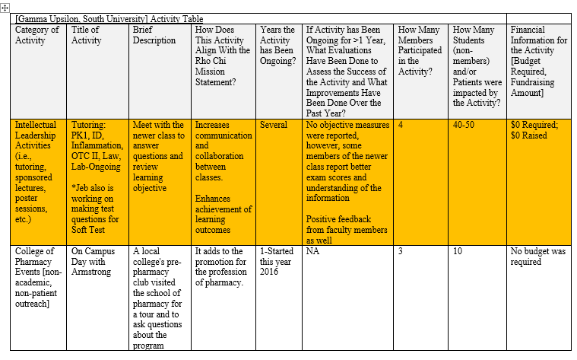
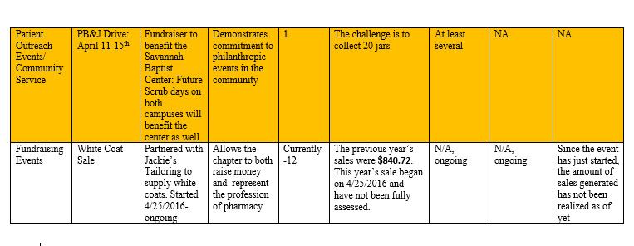

Financial/ Budgeting: Gamma Upsilon's budget was managed by Jeb Watkins (treasure) with input from other officers.
ITEM | Amount Debited | Amount Credited | Balance | Comment
Balance Forward |  |  | 1,124,32 | May 1, 2015
White Coat Sales |  | 840.72 | 1,965.04 | May 15
Lunch for Meeting | 106.00 |  | 1,859.04 | Aug 15
New member initiation fees |  | 3,240.00 | 5,099.04 | Sept 15
Initiation Dinner | 696.88 |  | 4,402.16 | Sept 15
New member cords | 250.00 |  | 4,152.16 | Sept 15
New member National Fees | 1,755.00 |  | 2,372.16 | Sept 15
Banking Supplies | 123.82 |  | 2,248.34 | Nov 15
Supplies | 186.40 |  | 2,061.94 | Dec 15
Lunch for Meeting | 152.40 |  | 1,909.54 | Jan 16
APhA delegate fee | 134.90 |  | 1774.64 | Feb 16
Student-Facuilty Bowling basket | 56.94 |  | 1717.70 | Mar 16

Initiation Function: Describe the initiation function, including when and where it took place, who attended it (not specific names), information on the speaker (if applicable), etc. (Limit 250 words)
The initiation ceremony for the Columbia, SC and Savannah, GA campuses were held separately.
The Rho Chi induction ceremony was held on November 3, 2015 in room 136 of the Columbia campus. Those in attendance included three Rho Chi members, Dr. Sarah Braga, new initiates, family members, and friends. The initiation ritual was carried out by Dr. Sarah Braga and three Rho Chi members from the class of 2016. (Jennifer Dix, Michael Miller, Anh Do) All initiation statements were read, and all new initiates were warmly welcomed into fellowship of the Rho Chi Honor Society.
Initiation for the Savannah campus was held on September 28th, 2015, at Bella's Italian Café. Present at the ceremony was new initiates, Rho Chi members and officers, Dr. Adeniji (advisor), family members, and friends. The induction ceremony was led by Janna Nevil, Kourtni Brewer, Caitlee Wilson, and Dr. Adegoke Adeniji. Our members were traditional induced, and as new members of Rho Chi, took their oath.

Evaluation/Reflection: Provide a reflective paragraph that evaluates the effectiveness of your activities and ways to improve. (Limit 500 words)
On behalf of the members of the Gamma Upsilon Chapter, we are all excited and honored by our acceptance into the Rho Chi Pharmacy Honor Society. We have effectively used this society to help other students achieve their goals within our school. By having frequent tutoring sessions, we help our peers achieve academic success. We have also expanded our philanthropic events this year to reach out to members of the communities outside of our pharmacy program. By increasing our presence on campus, our chapter has been commended by other student leaders and faculty for our commitment to service and excellence. We continually seek ways to raise funds besides just white coat sales. Overall, our chapter has branched out into other impactful activities and anticipate this will continue to happen.

Other information: If you would like to provide other information about your chapter that was not included in the above categories (e.g., development of a new website, organizing a regional meeting, etc.), add it here: (Limit 500 words)
Our chapter began a Facebook page to improve communication and sharing of photos and news between our campuses.

If your chapter would like to be considered for the Most Improved Chapter Award, please complete the following form on a separate page.

Most Improved Chapter Award

Some chapters have been relatively inactive in past years, but current students/advisors have made great strides to increase the activities/projects of their chapters. Rho Chi has instituted a designation for the “Most Improved Chapter Award” to recognize such strides. In order to be eligible for this award, a chapter must meet all the basic chapter requirements requested within the chapter annual report. Furthermore, the chapter annual report, names of elected officers, and the name of the chapter delegate to the Rho Chi Society National Office must be submitted to the Rho Chi National Office by the respective deadlines for each of these items. The chapter must send a representative to the Rho Chi Society Annual Meeting. In addition, chapters must have “active” chapter status for at least 2 consecutive years (e.g., new schools must be in at least the third year of chapter activity).

If your chapter would like to be considered for the “Most Improved Chapter Award,” indicate the significant improvement(s) of your chapter below. Limit to one page.

Name of School/College:

Chapter name and region:

Name of member submitting statement:

Name of Chapter Advisor:

